WaterVentures Outreach Vehicle Dimensions

The WaterVentures Outreach Truck is a full size tractor trailer rig. To ensure the safety of your students and our staff, please check for sufficient clearance in the area you plan to have our vehicle park. This includes building overhangs, turning radius, low hanging branches and other obstructions.

**The dimensions when set up are as follows:**

* Tractor, trailer and rear stairs are 83 feet long (trailer and stairs are 65 feet)
* Tractor and trailer are 14 ft. tall
* Trailer and side awning are 23 ft. wide
* Trailer alone is 9 ft. wide

Our staff can work with you to find a sufficient location on your campus.

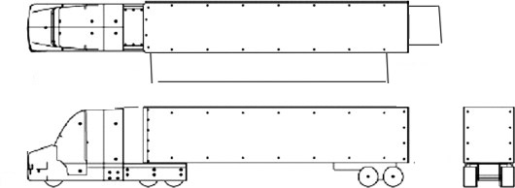

83 ft

14 ft

23 ft

14 ft

**Weight (with 1/2 tank of gas) – 54,640 pounds**

**Electricity – 50 AMP, 220/110 Volt (4 prong plug) or Generator**